**STRATEGIC MISSILE FACILITIES**

The command and control of the Minuteman and Peacekeeper strategic missile force is exercised from Launch Control Centers (LCCs). These LCCs are removed 20 to 150 miles from the central support base and a minimum of 14 miles from each other. The LCC itself is buried 40- 100 feet below ground and can be completely self sufficient for several weeks.

A crew of two officers operate all the systems in the LCC on a 24 hour shift. From the LCC, they remotely monitor their flight of ten missiles and backup another flight of ten.

The LCC is a spartan capsule with two launch consoles, communication equipment, a small lavatory and a bed. Anything can happen during an alert tour: Emergency War Order Message traffic, maintenance problems, electrical fires, or computer malfunctions. The time can be frantic or boring, an opportunity to study or a test of vigilance. One officer may sleep if the work load is light, while the other monitors the flight. Sleep may be difficult; operating noise in the LCC is often 70 dB and may exceed 90 dB during fully sealed operations. The Missile Crew Commander, and the deputy, even though they are only sitting ten feet from each other, must communicate with loud voices or by headphone during these conditions. In addition, perceptions of poor air quality in the LCC may add additional stress.

Entry to the LCC is controlled by the crew through an elevator leading down to the LCC. The crew must open a blast door that separates their capsule from the elevator exit. Due to the underground location, some LCCs have been known to have high airborne mold levels, occasionally causing allergic problems.

Topside, a small building holds security police, a cook and support personnel. All meals for launch officers are centrally prepared, frozen and sent out to the LCCs. The topside building is surrounded by a security fence and contains within its perimeter a number of radio communications antennas, some hardened against nuclear attack. Buried cables also connect the LCC to other command centers and to the missile silos.

**Crew Duties**

Missile combat crew duty is a four-year, stabilized tour. The initial assignment for crew members is normally as Deputy Missile Combat Crew Commander on a regular line crew. During this period, the crew member may progress to instructor, evaluator crew, or deputy flight commander status. Eventually, the position of Missile Combat Crew Commander may be assigned at the discretion of the Squadron Commander. In this position, the officer may command a regular line crew, instructor crew, or evaluation crew. Wing staff positions are available after completion of an initial tour of duty. Other career progressions may lead into space systems, flight commanders and higher command level jobs.

Minuteman and Peacekeeper crews have 24 hour alert tours, usually six to eight times a month. During these tours, the crew members remain in the Launch Control Centers and are responsible for monitoring all the activities of their flight of ten missiles as well as providing backup for a "sister" flight. This duty requires knowledge of complex systems management and significant problem-solving ability. Usually, sleep/rest periods of four to six hours are available to the crew during the tour. This varies considerably with readiness posture.

In addition to alert duties, a crew member completes an average of 15 hours of additional training a month. Topics include updates and refreshers on weapon system operations, Emergency War Orders (EWO), and practice sessions in the Missile Procedures Trainer (MPT). The MPT is a computerized, simulated launch control center and, much like aircraft simulators, presents situations that closely resemble actual weapon system situations.

The duties of the Missileers require a continuous, high level of mental alertness, combined with a schedule that provides very little off duty time. In their three-day rotation of alert/training/off, the day off may be only a half-day, creating stress within the missile officers' families; the stress is compounded by the feeling of isolation when missile bases are located in sparsely populated areas. Limited free time and the limited availability of social and recreational outlets can lead to chronic stress situations.

[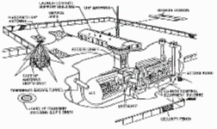](http://www.fas.org/nuke/guide/usa/icbm/fig_24-01.gif)[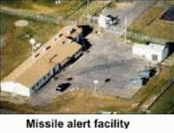](http://www.fas.org/nuke/guide/usa/icbm/mm3-maf.jpg)[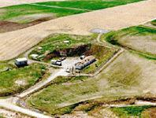](http://www.fas.org/nuke/guide/usa/icbm/lcf.jpg)  
[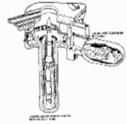](http://www.fas.org/nuke/guide/usa/icbm/fig_24-02.gif)[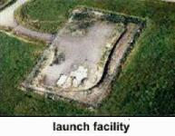](http://www.fas.org/nuke/guide/usa/icbm/mm3-lf.jpg)[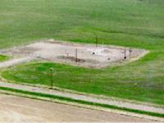](http://www.fas.org/nuke/guide/usa/icbm/lf.jpg)[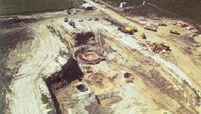](http://www.fas.org/nuke/guide/usa/icbm/mm3-lf-missile.jpg)